Nike Air Force 1 '07 Premium 2

$130
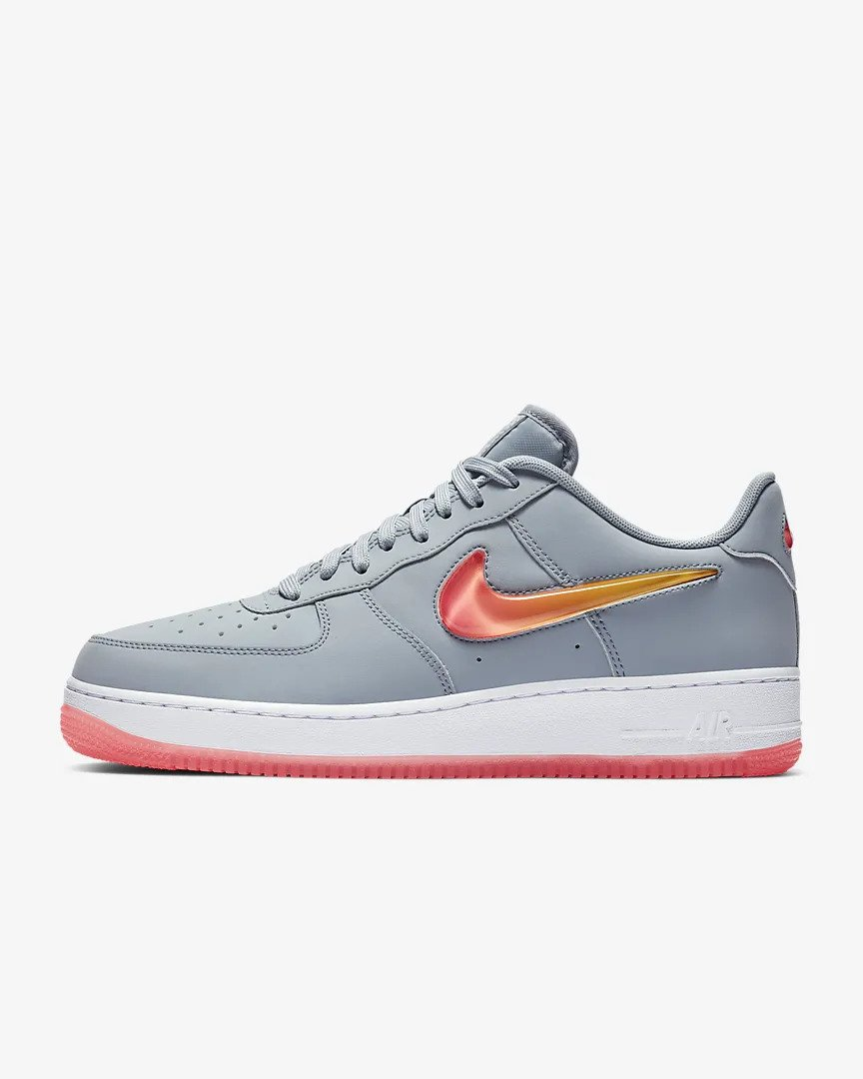
Details
- Leather and synthetic upper features a colorful jelly Swoosh design and back tab.
- Air-Sole unit offers cushioning.
- Sleek cupsole design has non-marking rubber for traction and durability.

